Marvelous Quran Tools
Yassine Amraoui

The Roadmap
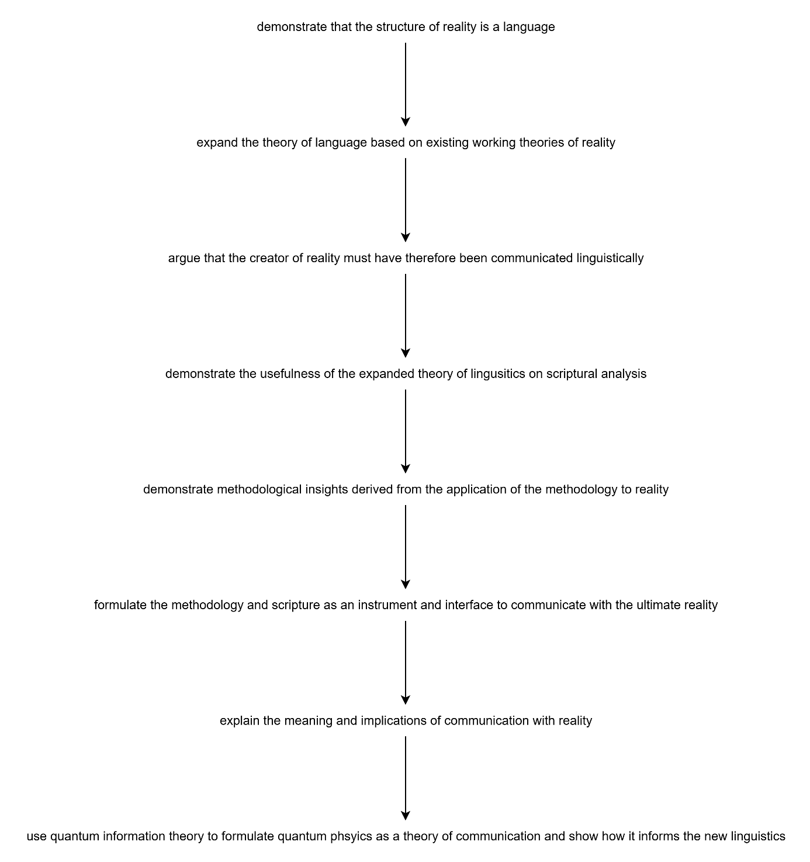

Search

1.1. Surah Search
Type the number of the surah to list all its ayat.

1.2. Ayah Search
Type the number the surah and ayah, separated by a colon. For example, if I want to display the first ayah of surah Ya-Seen, then I will type “36:1” into the command prompt, and the ayah in Arabic should show up almost instantly. No translations are included by default, but the Dr.Hany interpretation should be available soon.

1.3. Syntactic Pattern Search
Type

1.4. Morphological Pattern Search

1.5. Root Word Search
In order to search the ayat in the Quran where a specific root appears, type:
root [radical1] [radical2] [radical3], where each radical represents a letter from the root, and where the roots are defined using transliterations, in the following way:
ا = alif
ب = baa
ت = taa
ث = tha
ج = jym
ح = haa
خ = kha
د = dal
ذ = dhal
ر

1.6. Phonological Pattern Search
Some words in the Quran sound similar but are spelled differently. It would be useful if we could identify these similar-sounding words with different orthographies.

1.7 Stylistic Pattern Search
You only define a word once, and whenever you ask for the meaning of an ayah, it shows the definition of that word in all ayat in which the word appears, and shows the other undefined words as blank boxes, or shows them in arabic.
For example, if I define bismi in ayah 1:1, as ‘in the symbolism of’, then I ask for the meaning for that ayah, then it shows something like:
[in the symbolism of] [allah] [ar-rahman] [ar-raheem]
Or
[in the symbolism of] [???] [???] [???]
And if you search any ayah that has the word bismi, then it will show that word as [in the symbolism of] and all the other undefined words as [???]

Appendix
- What is my mission? What is my vision for my career and how does my mission towards Allah compare or contrast with it? I no longer really see my career as a means of changing the world. I have already presented a new model for global transformation. One that does not require much physical effort and little to no large-scale collaboration on the dimension of earthlings. But it does require lots of intellectual energy. What is it I want to build as a programmer? Will I be given the opportunity to build such a thing? Ultimately I want to create experiences that will enable people to get a better understanding of their role in this world, and basically present the new model of global transformation. In other words, my mission is tightly related to my mission towards Allah. Coding projects are particularly appealing because they never remain the same. They get updates, and usually the updates make the program better rather than worse. What is it I want to build? It’s a quran app, but it’s more than that. An app the gamifies the process of interpreting the scripture. Let’s recall, what’s the purpose of interpreting the scripture? To communicate with the real God. What or who is that? What does it mean to communicate with God?

- What I call ‘the gamification’ of Quranic interpretation, I essentially mean a software that willl facilitate data entry into a database and searching therefrom.

- # 3. Cool Projects
- - Cabrera research lab
- - [[Alison McDowell]]

- ## quote meaning guessing game
- A game where you are given a poem verse, quote, proverb, or literary passage and you are to guess what it means. The game is similar to semantle but.

Abstract Lexicon
A powerful tool for the analysis of Reality through Text as experienced by an Observer.

Outline

Purpose
I guess what I’m trying to build is not necessarily a system that will be used by a group, but by a single individual, and the system is meant to help the user learn more about themselves.

There are a few core components of this system

- Sensors to capture the more relevant data about yourself
- multimodal unstructured data entry
- formatting and structuring system
- Life Patterns Recognition
- all the most relevant data about yourself is captured. In existing solutions, this is done using manual logging, and I would like to automate some of this. Dashboard: the captured data is displayed to the user is a user-friendly way that enables them to notice patterns about themselves. Layers: the dashboard creates a summary of the captured data, but the user always has the possibility to unpack the complexity behind a single pattern. Through this process, the user should be able to inform the system on what aspects of themselves they want to focus on, what kind of patterns they want to keep an eye out for.
- Self-correcting goal system:
- the user’s define goals
- evaluation of user performance based on goals and success criteria.
- goal revision and updating based on user's changing reality and priorities

MAIN PROGRAM: Self Analysis
1. Record user daily log
a. Flexible data format
b. Identify key data points
- Emotions
- Visited locations
- Timestamps
c. Conversion to structured format to add to database
2. Match patterns between user log and Quran

Collaboration
We know there are benefits to collaboration. Some have capabilities or shortcomings that others don't. Each person can fill some of the gaps in the research of the other.
- keeping the bullshit meter very high and leaving room for doubt to avoid groupthink
- There is a community of practice without hierarchical structures, and no collective identity, no collective strategy or action.
- Individual action. We only collaborate in sharing personal results, insights and efforts.
- You should have non-religious organizations, political, economic, medical, etc. Human watch organization.

Community Self-Organization
- Simple interface: Users

Methodology
1. Questions
2. Gather all observations (root-word analysis, form analysis) (it’s an art and not an exact science)
3. Divine guidance, patience, dua, may take you on a detour to learn the pre-requisites. The answer to the dua is always positive given we understand.
4. Dhikrah. Never trust it.
5. Validation: go through all observations and see if the dhikrah fits with them. Plausibility of dhikrah.
6. Verification:
a. Active: More observations, beyond root-word analysis, examples that support our interpretation. Other janaah. Markings.
b. Passive: Disproving the dhikrah. What criteria will disprove your dhikrah? Address the potential refutations or arguments against the dhikrah. Passive verification never ends. We never have 100% certainty. This teaches cognitive plasticity.

Related Artifacts
- By matching the physical behavior of stallelite-tracked humans through their linguistically-centered social media presence, linguistic representations of socio-physical patterns can be used to catalogue successful socio-linguistic behavioral patterns along with their triggers.

